Ideation Phase

Brainstorm & Idea Prioritization Template

|  |  |
| --- | --- |
| DATE | 18 September 2022 |
| TEAM ID | PNT2022TMID30308 |
| PROJECT NAME | Real – Time River Water Quality Monitoring and Control System |
| MAXIMUM MARKS | 4 MARKS |

Step-1: Team Gathering, Collaboration and Select the Problem Statement

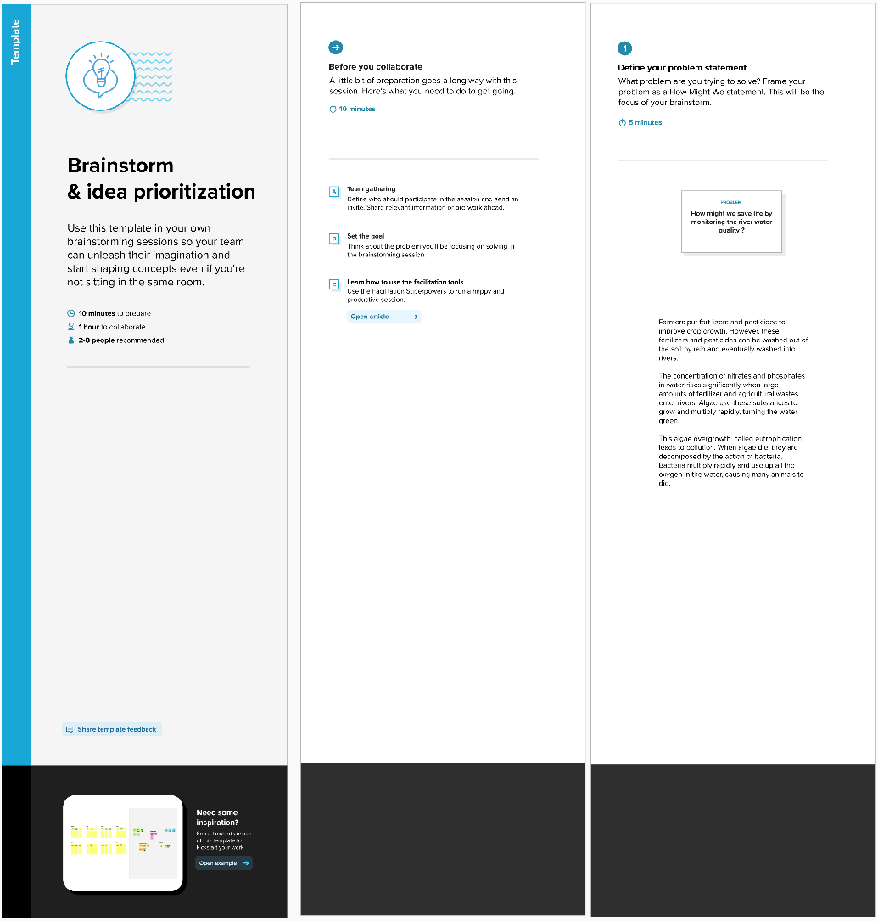

Step-2: Brainstorm, Idea Listing and Grouping

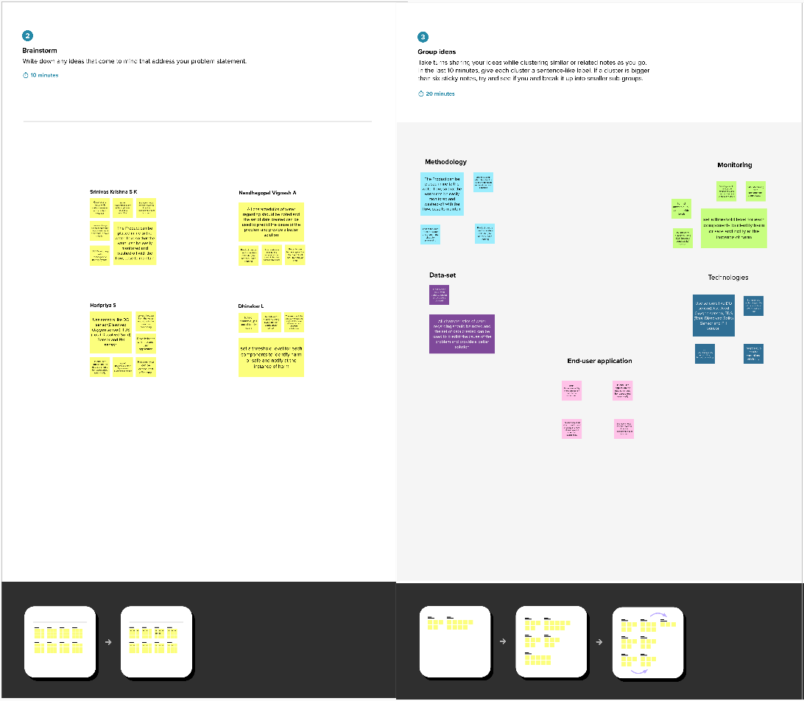

Step-3: Idea Prioritization

